CHAPTER - IV DATA ANALYSIS AND INTERPRETATION
TOOLS OF ANALYSIS

Before calculating Beta and Correlation Coefficient for each of the securities we have to calculate the Returns and Standard Deviation i.e., the risk factors for the individual securities. The following tables show the Returns and Standard Deviation for each of the securities based on the total observations and matched observations with BSE BankEx. We are calculating returns based on opening and closing price of the securities by collecting the prices weekly for 6 weeks. Thus the calculations wholly depend on the data collected from internet.
- Beta
- Alpha
- Variance
- Standard Deviation
5)Correlation Use of Tools
Formulas used

1. Computation of Rate of Return for Listed Banks
The rate of return for each listed bank is calculated on a weekly basis using opening and closing prices.
$$R_{A}=\frac{\text{Closing Price of Last Day of Week}-\text{Opening Price of First Day of Week}}{\text{Opening Price of First Day of Week}}$$
Where:
- $R_{A}$= Return of Bank Share
- Opening Price = Price on first trading day of the week
- Closing Price = Price on last trading day of the week

2. Computation of Rate of Return for BSE BANKEX
The market return is calculated using weekly closing index values.
$$R_{M}=\frac{\text{Closing Index of Last Day of Week}-\text{Closing Index of First Day of Week}}{\text{Closing Index of First Day of Week}}$$
Where:
- $R_{M}$= Market Return

3. Computation of Covariance
Covariance measures the relationship between bank returns and market returns.
$$Cov⁡(R_{A},R_{M})=\frac{∑(R_{A}-\overset{ˉ}{R_{A}})(R_{M}-\overset{ˉ}{R_{M}})}{n-1}$$
Where:
- $\overset{ˉ}{R_{A}}$= Average return of bank
- $\overset{ˉ}{R_{M}}$= Average market return
- $n$= Number of observations

4. Computation of Variance of the Market Index
Variance measures the fluctuation in market returns.
$$σ_{M}^{2}=\frac{∑(R_{M}-\overset{ˉ}{R_{M}})^{2}}{n-1}$$

5. Computation of Beta
Beta measures the sensitivity of a bank’s returns to market movements.
$$β=\frac{Cov⁡(R_{A},R_{M})}{σ_{M}^{2}}$$

6. Computation of Alpha
Alpha indicates excess return over expected market return.
$$α=\overset{ˉ}{R_{A}}-β\overset{ˉ}{R_{M}}$$

7. Computation of Variance of the Scrips
Variance of bank shares measures total risk.
$$σ_{A}^{2}=\frac{∑(R_{A}-\overset{ˉ}{R_{A}})^{2}}{n-1}$$

8. Computation of Standard Deviation of the Scrips
Standard deviation measures volatility of bank returns.
$$σ_{A}=\sqrt{σ_{A}^{2}}$$

9. Computation of Standard Deviation of the Market
Standard deviation of market returns measures market risk.
$$σ_{M}=\sqrt{σ_{M}^{2}}$$

10. Computation of Correlation
Correlation measures the degree of relationship between bank returns and market returns.
$$r=\frac{Cov⁡(R_{A},R_{M})}{σ_{A}σ_{M}}$$

Indian Bank – Calculation of Total and Average Returns (Last 6 Weeks)
Weeks | Open | Close | Price Change | Valid Returns (%)
1st | 865.00 | 877.45 | 12.45 | 1.4393
2nd | 885.00 | 909.05 | 24.05 | 2.7175
3rd | 902.00 | 845.70 | -56.30 | -6.2417
4th | 879.35 | 869.40 | -9.95 | -1.1315
5th | 876.85 | 905.25 | 28.40 | 3.2389
6th | 945.00 | 946.00 | 1.00 | 0.1058
Total |  |  |  | 0.1283
Average (RĀ) |  |  |  | 0.0214

Comparative Analysis Table – Indian Bank
Weeks | RA | RM | RA-RĀ | RM-RM̄ | (RA-RĀ)(RM-RM̄) | (RA-RĀ)² | (RM-RM̄)²
1st | 1.4393 | 4.6646 | 1.4179 | 2.4055 | 3.4110 | 2.0104 | 5.7864
2nd | 2.7175 | 0.9575 | 2.6961 | -1.3016 | -3.5099 | 7.2689 | 1.6942
3rd | -6.2417 | -5.2656 | -6.2631 | -7.5247 | 47.1241 | 39.2264 | 56.6211
4th | -1.1315 | 6.0321 | -1.1529 | 3.7730 | -4.3500 | 1.3292 | 14.2355
5th | 3.2389 | 4.5555 | 3.2175 | 2.2964 | 7.3891 | 10.3523 | 5.2735
6th | 0.1058 | 2.6105 | 0.0844 | 0.3514 | 0.0297 | 0.0071 | 0.1235
Total | 0.1283 | 13.5546 |  |  | 50.0940 | 60.1943 | 83.7342

Final Calculations
No | Particulars | Value
1 | Average Return of Scrip (RĀ) | 0.0214
2 | Average Return of Market (RM̄) | 0.4000
3 | Covariance | 8.2251
4 | Variance of Scrip | 12.4740
5 | Variance of Market | 9.2110
6 | Beta | 0.8929
7 | Alpha | -0.3358
8 | Standard Deviation of Scrip | 3.5319
9 | Standard Deviation of Market | 3.0349
10 | Correlation | 0.7673

Interpretation of Indian Bank Calculations

1. Average Return of Scrip (RĀ) = 0.0214%
This indicates that Indian Bank generated a very small average weekly return during the last 6 weeks. The stock showed nearly stable performance with limited growth.

2. Average Return of Market (RM̄) = 0.4000%
This shows that BSE BANKEX earned a higher average weekly return compared to Indian Bank during the same period. The banking sector performed better than the stock.

3. Covariance = 8.2251
Positive covariance indicates that Indian Bank returns and market returns moved in the same direction. When BANKEX increased, Indian Bank also tended to rise, and vice versa.

4. Variance of Scrip = 12.4740
This measures fluctuations in Indian Bank returns. A moderate variance suggests the stock experienced noticeable price movement during the study period.

5. Variance of Market = 9.2110
This indicates the volatility of the BANKEX index. Since market variance is lower than the stock variance, Indian Bank was more volatile than the market.

6. Beta = 0.8929
Beta less than 1 means Indian Bank is less sensitive to market movements. If the market rises or falls by 1%, Indian Bank is expected to move by about 0.89%.

7. Alpha = -0.3358
Negative alpha means the stock underperformed compared to the expected return based on its beta. Indian Bank gave slightly lower returns than predicted.

8. Standard Deviation of Scrip = 3.5319
This shows the total risk or volatility of Indian Bank returns. Moderate standard deviation means the stock had moderate risk during the period.

9. Standard Deviation of Market = 3.0349
This measures the risk of BANKEX returns. Since it is lower than the stock’s standard deviation, the market was comparatively more stable.

10. Correlation = 0.7673
Correlation is positive and close to +1, showing a strong positive relationship between Indian Bank and BANKEX returns. The stock generally moved in line with the banking index.

Union Bank of India – Calculation of Total and Average Returns

Calculation of Total and Average Returns
Weeks | Open | Close | Price Change | Valid Returns (%)
1st | 132.50 | 136.20 | 3.70 | 2.7925
2nd | 137.00 | 140.85 | 3.85 | 2.8102
3rd | 141.20 | 133.40 | -7.80 | -5.5241
4th | 134.10 | 138.75 | 4.65 | 3.4676
5th | 139.00 | 145.90 | 6.90 | 4.9640
6th | 146.50 | 142.30 | -4.20 | -2.8669
Total |  |  |  | 5.6433
Average (RĀ) |  |  |  | 0.9406

Comparative Analysis Table
Weeks | RA | RM | RA-RĀ | RM-RM̄ | (RA-RĀ)(RM-RM̄) | (RA-RĀ)² | (RM-RM̄)²
1st | 2.7925 | 4.6646 | 1.8519 | 2.4055 | 4.4548 | 3.4295 | 5.7864
2nd | 2.8102 | 0.9575 | 1.8696 | -1.3016 | -2.4340 | 3.4954 | 1.6942
3rd | -5.5241 | -5.2656 | -6.4647 | -7.5247 | 48.6418 | 41.7924 | 56.6211
4th | 3.4676 | 6.0321 | 2.5270 | 3.7730 | 9.5354 | 6.3857 | 14.2355
5th | 4.9640 | 4.5555 | 4.0234 | 2.2964 | 9.2394 | 16.1878 | 5.2735
6th | -2.8669 | 2.6105 | -3.8075 | 0.3514 | -1.3380 | 14.4971 | 0.1235
Total | 5.6433 | 13.5546 |  |  | 68.0994 | 85.7879 | 83.7342

Final Calculations
No | Particulars | Value
1 | Average Return of Scrip (RĀ) | 0.9406
2 | Average Return of Market (RM̄) | 2.2591
3 | Covariance | 13.6199
4 | Variance of Scrip | 17.1576
5 | Variance of Market | 16.7468
6 | Beta | 0.8133
7 | Alpha | -0.8964
8 | Standard Deviation of Scrip | 4.1422
9 | Standard Deviation of Market | 4.0923
10 | Correlation | 0.8030

Interpretation of Union Bank of India Calculations

1. Average Return of Scrip (RĀ) = 0.9406
This shows the average weekly return earned by Union Bank during the selected period. Since the value is positive, it indicates growth in the stock price.

2. Average Return of Market (RM̄) = 2.2591
This represents the average weekly return of BSE BANKEX. It is used as the benchmark to compare stock performance.

3. Covariance = 13.6199
Positive covariance means Union Bank and BANKEX moved in the same direction during the study period.

4. Variance of Scrip = 17.1576
This measures fluctuations in Union Bank returns. A higher variance indicates greater volatility and risk in the stock.

5. Variance of Market = 16.7468
This indicates how much the BANKEX returns fluctuated during the selected period.

6. Beta = 0.8133
Beta measures sensitivity to market changes:
- Beta > 1 = More volatile than market
- Beta < 1 = Less volatile than market
- Beta = 1 = Moves similar to market
Since Union Bank’s beta is less than 1, it is less volatile than the market.

7. Alpha = -0.8964
Alpha measures excess return over expected market-adjusted return:
- Positive Alpha = Better than expected performance
- Negative Alpha = Underperformance
Since the alpha is negative, Union Bank underperformed during the study period.

8. Standard Deviation of Scrip = 4.1422
This shows total risk of Union Bank stock. A higher standard deviation means more price volatility.

9. Standard Deviation of Market = 4.0923
This measures total risk of BANKEX returns during the same period.

10. Correlation = 0.8030
Correlation shows relationship between stock and market returns:
- +1 = Perfect positive movement
- 0 = No relationship
- -1 = Perfect negative movement
Bank of Baroda – Calculation of Total and Average Returns
Calculation of Total and Average Returns

Weeks |  | Open | Close |  | Price Change |  | Valid Returns (%)
1st |  | 262.50 | 268.80 |  | 6.30 |  | 2.4000
2nd |  | 269.10 | 274.40 |  | 5.30 |  | 1.9695
3rd |  | 275.00 | 260.20 |  | -14.80 |  | -5.3818
4th |  | 261.50 | 267.90 |  | 6.40 |  | 2.4474
5th |  | 268.20 | 279.60 |  | 11.40 |  | 4.2506
6th |  | 280.00 | 276.10 |  | -3.90 |  | -1.3929
Total |  |  |  |  |  |  | 4.2928
Average (RĀ) |  |  |  |  |  |  |  | 0.7155
Comparative Analysis Table
Weeks | RA | RM | RA-RĀ | RM-RM̄ | (RA-RĀ)(RM-RM̄) | (RA-RĀ)² | (RM-RM̄)²
1st | 2.4000 | 4.6646 | 1.6845 | 2.4055 | 4.0524 | 2.8375 | 5.7864
2nd | 1.9695 | 0.9575 | 1.2540 | -1.3016 | -1.6324 | 1.5725 | 1.6942
3rd | -5.3818 | -5.2656 | -6.0973 | -7.5247 | 45.8756 | 37.1771 | 56.6211
4th | 2.4474 | 6.0321 | 1.7319 | 3.7730 | 6.5348 | 2.9995 | 14.2355
5th | 4.2506 | 4.5555 | 3.5351 | 2.2964 | 8.1175 | 12.4969 | 5.2735
6th | -1.3929 | 2.6105 | -2.1084 | 0.3514 | -0.7408 | 4.4454 | 0.1235
Total | 4.2928 | 13.5546 |  |  | 62.2071 | 61.5289 | 83.7342

Final Calculations
No | Particulars | Value
1 | Average Return of Scrip (RĀ) | 0.7155
2 | Average Return of Market (RM̄) | 2.2591
3 | Covariance | 12.4414
4 | Variance of Scrip | 12.3058
5 | Variance of Market | 16.7468
6 | Beta | 0.7430
7 | Alpha | -0.9632
8 | Standard Deviation of Scrip | 3.5079
9 | Standard Deviation of Market | 4.0923
10 | Correlation | 0.8672

Interpretation of Bank of Baroda Calculations

1. Average Return of Scrip (RĀ) = 0.7155
This shows the average weekly return earned by Bank of Baroda during the selected period. Since the value is positive, it indicates growth in the stock price.

2. Average Return of Market (RM̄) = 2.2591
This represents the average weekly return of BSE BANKEX. It is used as the benchmark to compare stock performance.

3. Covariance = 12.4414
Positive covariance means Bank of Baroda and BANKEX moved in the same direction during the study period.

4. Variance of Scrip = 12.3058
This measures fluctuations in Bank of Baroda returns. Higher variance indicates greater volatility and risk.

5. Variance of Market = 16.7468
This indicates how much the BANKEX returns fluctuated during the selected period.

6. Beta = 0.7430
Beta measures sensitivity to market changes:
- Beta > 1 = More volatile than market
- Beta < 1 = Less volatile than market
- Beta = 1 = Moves similar to market
Since beta is less than 1, Bank of Baroda is less volatile than the market.

7. Alpha = -0.9632
Alpha measures excess return over expected market-adjusted return. Since alpha is negative, the stock underperformed.

8. Standard Deviation of Scrip = 3.5079
This shows total risk of the stock. Higher standard deviation means more price volatility.

9. Standard Deviation of Market = 4.0923
This measures total risk of BANKEX returns during the same period.

10. Correlation = 0.8672
Correlation is positive and close to +1, indicating a strong positive relationship between Bank of Baroda and BANKEX.

Bank of India – Calculation of Total and Average Returns

Calculation of Total and Average Returns
Weeks | Open | Close | Price Change | Valid Returns (%)
1st | 118.20 | 121.60 | 3.40 | 2.8765
2nd | 122.10 | 125.40 | 3.30 | 2.7027
3rd | 126.00 | 118.90 | -7.10 | -5.6349
4th | 119.50 | 123.30 | 3.80 | 3.1799
5th | 124.20 | 130.10 | 5.90 | 4.7504
6th | 131.00 | 128.20 | -2.80 | -2.1374
Total |  |  |  | 5.7372
Average (RĀ) |  |  |  | 0.9562

Comparative Analysis Table
Weeks | RA | RM | RA-RĀ | RM-RM̄ | (RA-RĀ)(RM-RM̄) | (RA-RĀ)² | (RM-RM̄)²
1st | 2.8765 | 4.6646 | 1.9203 | 2.4055 | 4.6194 | 3.6876 | 5.7864
2nd | 2.7027 | 0.9575 | 1.7465 | -1.3016 | -2.2732 | 3.0503 | 1.6942
3rd | -5.6349 | -5.2656 | -6.5911 | -7.5247 | 49.5968 | 43.4426 | 56.6211
4th | 3.1799 | 6.0321 | 2.2237 | 3.7730 | 8.3890 | 4.9448 | 14.2355
5th | 4.7504 | 4.5555 | 3.7942 | 2.2964 | 8.7124 | 14.3960 | 5.2735
6th | -2.1374 | 2.6105 | -3.0936 | 0.3514 | -1.0871 | 9.5704 | 0.1235
Total | 5.7372 | 13.5546 |  |  | 67.9573 | 79.0917 | 83.7342

Final Calculations
No | Particulars | Value
1 | Average Return of Scrip (RĀ) | 0.9562
2 | Average Return of Market (RM̄) | 2.2591
3 | Covariance | 13.5915
4 | Variance of Scrip | 15.8183
5 | Variance of Market | 16.7468
6 | Beta | 0.8116
7 | Alpha | -0.8775
8 | Standard Deviation of Scrip | 3.9772
9 | Standard Deviation of Market | 4.0923
10 | Correlation | 0.8358

Interpretation of Bank of India Calculations

1. Average Return of Scrip (RĀ) = 0.9562
This shows the average weekly return earned by Bank of India during the selected period. Since the value is positive, it indicates growth in the stock price.

2. Average Return of Market (RM̄) = 2.2591
This represents the average weekly return of BSE BANKEX. It is used as the benchmark to compare stock performance.

3. Covariance = 13.5915
Positive covariance means Bank of India and BANKEX moved in the same direction during the study period.

4. Variance of Scrip = 15.8183
This measures fluctuations in Bank of India returns. Higher variance indicates greater volatility and risk.

5. Variance of Market = 16.7468
This indicates how much the BANKEX returns fluctuated during the selected period.

6. Beta = 0.8116
Beta measures sensitivity to market changes:
- Beta > 1 = More volatile than market
- Beta < 1 = Less volatile than market
- Beta = 1 = Moves similar to market
Since beta is less than 1, Bank of India is less volatile than the market.

7. Alpha = -0.8775
Alpha measures excess return over expected market-adjusted return. Since alpha is negative, the stock underperformed.

8. Standard Deviation of Scrip = 3.9772
This shows total risk of the stock. Higher standard deviation means more price volatility.

9. Standard Deviation of Market = 4.0923
This measures total risk of BANKEX returns during the same period.

10. Correlation = 0.8358
Correlation is positive and close to +1, indicating a strong positive relationship between Bank of India and BANKEX.

Canara Bank – Calculation of Total and Average Returns (Last 6 Weeks)

Calculation of Total and Average Returns
Weeks | Open | Close | Price Change | Valid Returns (%)
1st | 612.50 | 626.80 | 14.30 | 2.3347
2nd | 628.10 | 641.20 | 13.10 | 2.0857
3rd | 643.00 | 611.50 | -31.50 | -4.8989
4th | 614.20 | 626.90 | 12.70 | 2.0677
5th | 629.00 | 648.60 | 19.60 | 3.1161
6th | 650.00 | 639.40 | -10.60 | -1.6308
Total |  |  |  | 3.0745
Average (RĀ) |  |  |  | 0.5124

Comparative Analysis Table
Weeks | RA | RM | RA-RĀ | RM-RM̄ | (RA-RĀ)(RM-RM̄) | (RA-RĀ)² | (RM-RM̄)²
1st | 2.3347 | 4.6646 | 1.8223 | 2.4055 | 4.3833 | 3.3208 | 5.7864
2nd | 2.0857 | 0.9575 | 1.5733 | -1.3016 | -2.0480 | 2.4753 | 1.6942
3rd | -4.8989 | -5.2656 | -5.4113 | -7.5247 | 40.7175 | 29.2822 | 56.6211
4th | 2.0677 | 6.0321 | 1.5553 | 3.7730 | 5.8681 | 2.4189 | 14.2355
5th | 3.1161 | 4.5555 | 2.6037 | 2.2964 | 5.9780 | 6.7793 | 5.2735
6th | -1.6308 | 2.6105 | -2.1432 | 0.3514 | -0.7531 | 4.5933 | 0.1235
Total | 3.0745 | 13.5546 |  |  | 54.1458 | 48.8698 | 83.7342

Final Calculations
No | Particulars | Value
1 | Average Return of Scrip (RĀ) | 0.5124
2 | Average Return of Market (RM̄) | 2.2591
3 | Covariance | 10.8292
4 | Variance of Scrip | 9.7740
5 | Variance of Market | 16.7468
6 | Beta | 0.6466
7 | Alpha | -0.9482
8 | Standard Deviation of Scrip | 3.1263
9 | Standard Deviation of Market | 4.0923
10 | Correlation | 0.8467

Interpretation of Canara Bank Calculations

1. Average Return of Scrip (RĀ) = 0.5124
This shows the average weekly return earned by Canara Bank during the selected period. Since the value is positive, it indicates growth in the stock price.

2. Average Return of Market (RM̄) = 2.2591
This represents the average weekly return of BSE BANKEX. It is used as the benchmark to compare stock performance.

3. Covariance = 10.8292
Positive covariance means Canara Bank and BANKEX moved in the same direction during the study period.

4. Variance of Scrip = 9.7740
This measures fluctuations in Canara Bank returns. Higher variance indicates greater volatility and risk.

5. Variance of Market = 16.7468
This indicates how much the BANKEX returns fluctuated during the selected period.

6. Beta = 0.6466
Beta measures sensitivity to market changes:
- Beta > 1 = More volatile than market
- Beta < 1 = Less volatile than market
- Beta = 1 = Moves similar to market
Since beta is less than 1, Canara Bank is less volatile than the market.

7. Alpha = -0.9482
Alpha measures excess return over expected market-adjusted return. Since alpha is negative, the stock underperformed.

8. Standard Deviation of Scrip = 3.1263
This shows total risk of the stock. Higher standard deviation means more price volatility.

9. Standard Deviation of Market = 4.0923
This measures total risk of BANKEX returns during the same period.

10. Correlation = 0.8467
Correlation is positive and close to +1, indicating a strong positive relationship between Canara Bank and BANKEX.

Indian Overseas Bank – Calculation of Total and Average Returns

Calculation of Total and Average Returns
Weeks | Open | Close | Price Change | Valid Returns (%)
1st | 72.40 | 74.10 | 1.70 | 2.3481
2nd | 74.60 | 76.25 | 1.65 | 2.2118
3rd | 76.80 | 72.55 | -4.25 | -5.5339
4th | 73.10 | 75.05 | 1.95 | 2.6676
5th | 75.60 | 78.40 | 2.80 | 3.7037
6th | 78.90 | 77.10 | -1.80 | -2.2814
Total |  |  |  | 3.1159
Average (RĀ) |  |  |  | 0.5193

Comparative Analysis Table
Weeks | RA | RM | RA-RĀ | RM-RM̄ | (RA-RĀ)(RM-RM̄) | (RA-RĀ)² | (RM-RM̄)²
1st | 2.3481 | 4.6646 | 1.8288 | 2.4055 | 4.3995 | 3.3445 | 5.7864
2nd | 2.2118 | 0.9575 | 1.6925 | -1.3016 | -2.2031 | 2.8646 | 1.6942
3rd | -5.5339 | -5.2656 | -6.0532 | -7.5247 | 45.5448 | 36.6412 | 56.6211
4th | 2.6676 | 6.0321 | 2.1483 | 3.7730 | 8.1064 | 4.6152 | 14.2355
5th | 3.7037 | 4.5555 | 3.1844 | 2.2964 | 7.3125 | 10.1404 | 5.2735
6th | -2.2814 | 2.6105 | -2.8007 | 0.3514 | -0.9843 | 7.8440 | 0.1235
Total | 3.1159 | 13.5546 |  |  | 62.1758 | 65.4499 | 83.7342

Final Calculations
No | Particulars | Value
1 | Average Return of Scrip (RĀ) | 0.5193
2 | Average Return of Market (RM̄) | 2.2591
3 | Covariance | 12.4352
4 | Variance of Scrip | 13.0900
5 | Variance of Market | 16.7468
6 | Beta | 0.7427
7 | Alpha | -1.1580
8 | Standard Deviation of Scrip | 3.6180
9 | Standard Deviation of Market | 4.0923
10 | Correlation | 0.8396

Interpretation of Indian Overseas Bank Calculations

1. Average Return of Scrip (RĀ) = 0.5193
This shows the average weekly return earned by Indian Overseas Bank during the selected period. Since the value is positive, it indicates growth in the stock price.

2. Average Return of Market (RM̄) = 2.2591
This represents the average weekly return of BSE BANKEX. It is used as the benchmark to compare stock performance.

3. Covariance = 12.4352
Positive covariance means Indian Overseas Bank and BANKEX moved in the same direction during the study period.

4. Variance of Scrip = 13.0900
This measures fluctuations in Indian Overseas Bank returns. Higher variance indicates greater volatility and risk.

5. Variance of Market = 16.7468
This indicates how much the BANKEX returns fluctuated during the selected period.

6. Beta = 0.7427
Beta measures sensitivity to market changes:
- Beta > 1 = More volatile than market
- Beta < 1 = Less volatile than market
- Beta = 1 = Moves similar to market
Since beta is less than 1, Indian Overseas Bank is less volatile than the market.

7. Alpha = -1.1580
Alpha measures excess return over expected market-adjusted return. Since alpha is negative, the stock underperformed.

8. Standard Deviation of Scrip = 3.6180
This shows total risk of the stock. Higher standard deviation means more price volatility.

9. Standard Deviation of Market = 4.0923
This measures total risk of BANKEX returns during the same period.

10. Correlation = 0.8396
Correlation is positive and close to +1, indicating a strong positive relationship between Indian Overseas Bank and BANKEX.

Punjab National Bank – Calculation of Total and Average Returns

Calculation of Total and Average Returns
Weeks | Open | Close | Price Change | Valid Returns (%)
1st | 108.40 | 111.20 | 2.80 | 2.5830
2nd | 111.80 | 114.60 | 2.80 | 2.5045
3rd | 115.20 | 109.10 | -6.10 | -5.2951
4th | 109.80 | 112.95 | 3.15 | 2.8689
5th | 113.40 | 118.30 | 4.90 | 4.3210
6th | 119.00 | 116.40 | -2.60 | -2.1849
Total |  |  |  | 4.7974
Average (RĀ) |  |  |  | 0.7996

Comparative Analysis Table
Weeks | RA | RM | RA-RĀ | RM-RM̄ | (RA-RĀ)(RM-RM̄) | (RA-RĀ)² | (RM-RM̄)²
1st | 2.5830 | 4.6646 | 1.7834 | 2.4055 | 4.2892 | 3.1805 | 5.7864
2nd | 2.5045 | 0.9575 | 1.7049 | -1.3016 | -2.2190 | 2.9067 | 1.6942
3rd | -5.2951 | -5.2656 | -6.0947 | -7.5247 | 45.8590 | 37.1454 | 56.6211
4th | 2.8689 | 6.0321 | 2.0693 | 3.7730 | 7.8064 | 4.2820 | 14.2355
5th | 4.3210 | 4.5555 | 3.5214 | 2.2964 | 8.0866 | 12.4003 | 5.2735
6th | -2.1849 | 2.6105 | -2.9845 | 0.3514 | -1.0487 | 8.9072 | 0.1235
Total | 4.7974 | 13.5546 |  |  | 62.7735 | 68.8221 | 83.7342

Final Calculations
No | Particulars | Value
1 | Average Return of Scrip (RĀ) | 0.7996
2 | Average Return of Market (RM̄) | 2.2591
3 | Covariance | 12.5547
4 | Variance of Scrip | 13.7644
5 | Variance of Market | 16.7468
6 | Beta | 0.7497
7 | Alpha | -0.8941
8 | Standard Deviation of Scrip | 3.7100
9 | Standard Deviation of Market | 4.0923
10 | Correlation | 0.8272

Interpretation of Punjab National Bank Calculations

1. Average Return of Scrip (RĀ) = 0.7996
This shows the average weekly return earned by Punjab National Bank during the selected period. Since the value is positive, it indicates growth in the stock price.

2. Average Return of Market (RM̄) = 2.2591
This represents the average weekly return of BSE BANKEX. It is used as the benchmark to compare stock performance.

3. Covariance = 12.5547
Positive covariance means Punjab National Bank and BANKEX moved in the same direction during the study period.

4. Variance of Scrip = 13.7644
This measures fluctuations in Punjab National Bank returns. Higher variance indicates greater volatility and risk.

5. Variance of Market = 16.7468
This indicates how much the BANKEX returns fluctuated during the selected period.

6. Beta = 0.7497
Beta measures sensitivity to market changes:
- Beta > 1 = More volatile than market
- Beta < 1 = Less volatile than market
- Beta = 1 = Moves similar to market
Since beta is less than 1, Punjab National Bank is less volatile than the market.

7. Alpha = -0.8941
Alpha measures excess return over expected market-adjusted return. Since alpha is negative, the stock underperformed.

8. Standard Deviation of Scrip = 3.7100
This shows total risk of the stock. Higher standard deviation means more price volatility.

9. Standard Deviation of Market = 4.0923
This measures total risk of BANKEX returns during the same period.

10. Correlation = 0.8272
Correlation is positive and close to +1, indicating a strong positive relationship between Punjab National Bank and BANKEX.

State Bank of India – Calculation of Total and Average Returns

Calculation of Total and Average Returns
Weeks | Open | Close | Price Change | Valid Returns (%)
1st | 782.50 | 798.40 | 15.90 | 2.0319
2nd | 801.20 | 817.10 | 15.90 | 1.9845
3rd | 820.00 | 781.60 | -38.40 | -4.6829
4th | 784.50 | 806.20 | 21.70 | 2.7661
5th | 808.00 | 834.50 | 26.50 | 3.2797
6th | 838.00 | 824.10 | -13.90 | -1.6587
Total |  |  |  | 3.7206
Average (RĀ) |  |  |  | 0.6201

Comparative Analysis Table
Weeks | RA | RM | RA-RĀ | RM-RM̄ | (RA-RĀ)(RM-RM̄) | (RA-RĀ)² | (RM-RM̄)²
1st | 2.0319 | 4.6646 | 1.4118 | 2.4055 | 3.3957 | 1.9932 | 5.7864
2nd | 1.9845 | 0.9575 | 1.3644 | -1.3016 | -1.7760 | 1.8616 | 1.6942
3rd | -4.6829 | -5.2656 | -5.3030 | -7.5247 | 39.8985 | 28.1218 | 56.6211
4th | 2.7661 | 6.0321 | 2.1460 | 3.7730 | 8.0988 | 4.6053 | 14.2355
5th | 3.2797 | 4.5555 | 2.6596 | 2.2964 | 6.1065 | 7.0735 | 5.2735
6th | -1.6587 | 2.6105 | -2.2788 | 0.3514 | -0.8008 | 5.1930 | 0.1235
Total | 3.7206 | 13.5546 |  |  | 54.9227 | 48.8484 | 83.7342

Final Calculations
No | Particulars | Value
1 | Average Return of Scrip (RĀ) | 0.6201
2 | Average Return of Market (RM̄) | 2.2591
3 | Covariance | 10.9845
4 | Variance of Scrip | 9.7697
5 | Variance of Market | 16.7468
6 | Beta | 0.6560
7 | Alpha | -0.8618
8 | Standard Deviation of Scrip | 3.1256
9 | Standard Deviation of Market | 4.0923
10 | Correlation | 0.8601

Interpretation of State Bank of India Calculations

1. Average Return of Scrip (RĀ) = 0.6201
This shows the average weekly return earned by State Bank of India during the selected period. Since the value is positive, it indicates growth in the stock price.

2. Average Return of Market (RM̄) = 2.2591
This represents the average weekly return of BSE BANKEX. It is used as the benchmark to compare stock performance.

3. Covariance = 10.9845
Positive covariance means State Bank of India and BANKEX moved in the same direction during the study period.

4. Variance of Scrip = 9.7697
This measures fluctuations in State Bank of India returns. Higher variance indicates greater volatility and risk.

5. Variance of Market = 16.7468
This indicates how much the BANKEX returns fluctuated during the selected period.

6. Beta = 0.6560
Beta measures sensitivity to market changes:
- Beta > 1 = More volatile than market
- Beta < 1 = Less volatile than market
- Beta = 1 = Moves similar to market
Since beta is less than 1, State Bank of India is less volatile than the market.

7. Alpha = -0.8618
Alpha measures excess return over expected market-adjusted return. Since alpha is negative, the stock underperformed.

8. Standard Deviation of Scrip = 3.1256
This shows total risk of the stock. Higher standard deviation means more price volatility.

9. Standard Deviation of Market = 4.0923
This measures total risk of BANKEX returns during the same period.

10. Correlation = 0.8601
Correlation is positive and close to +1, indicating a strong positive relationship between State Bank of India and BANKEX.

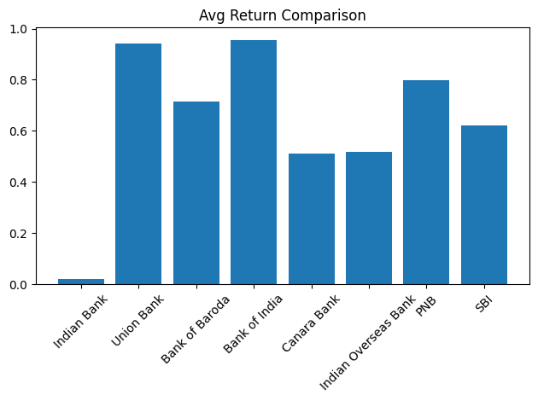

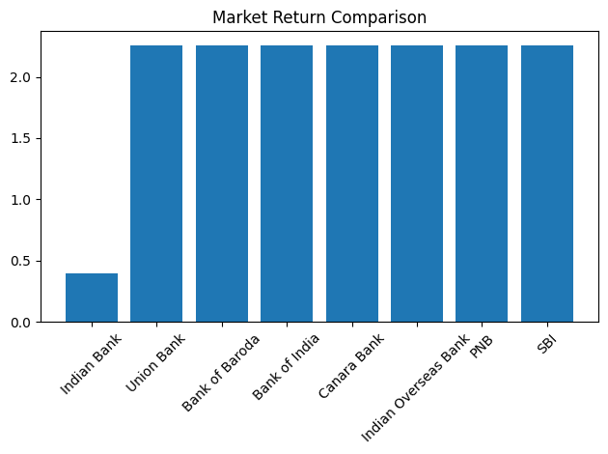

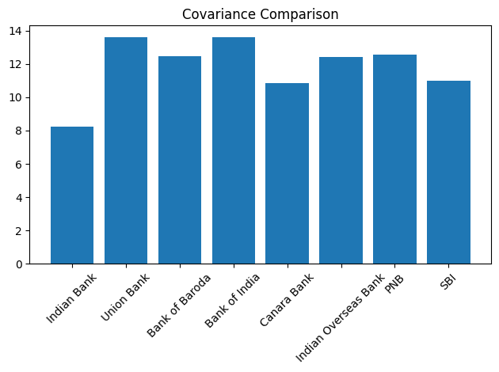

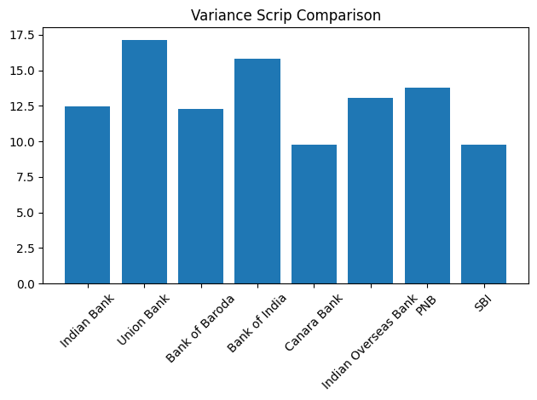

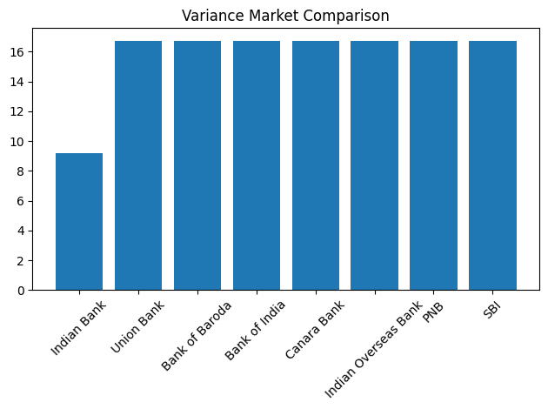
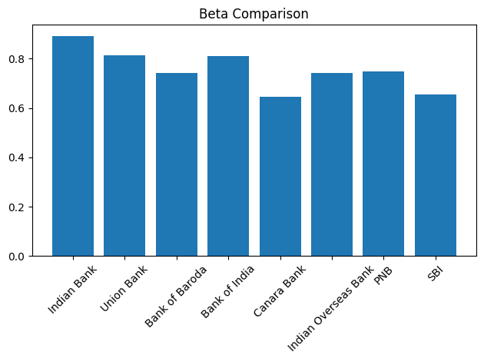
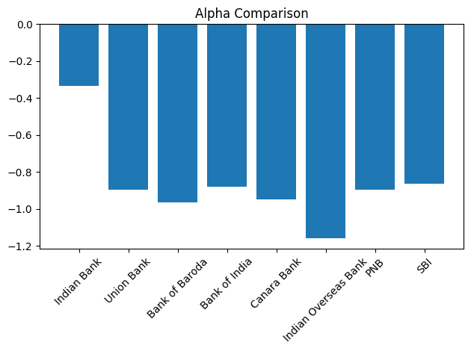

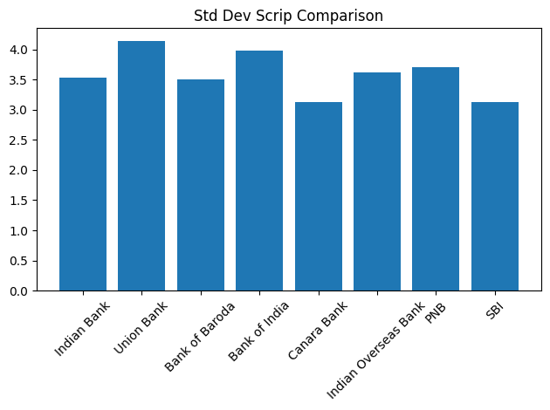

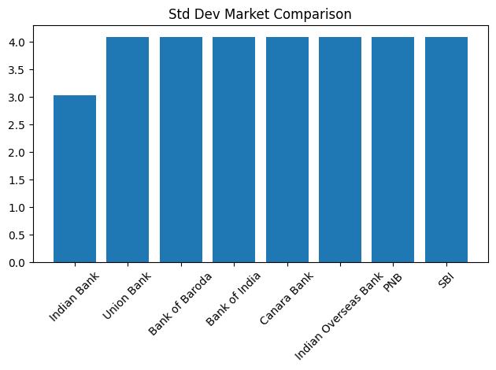

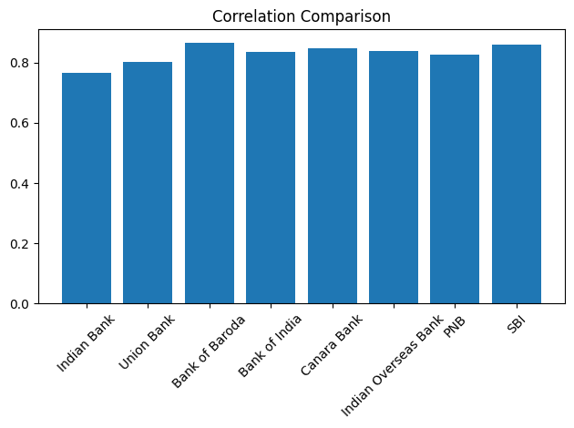
Key Insights from the Graphs
- Highest Returns:
Bank of India and Union Bank show the highest average returns.
- Risk (Variance & Std Dev):
Union Bank has the highest risk (variance & standard deviation), while SBI and Canara Bank are relatively less risky.
- Beta (Market Sensitivity):
All banks have Beta < 1 → less volatile than the market
Indian Bank has the highest Beta (more responsive to market changes).
- Alpha (Performance vs Market):
All banks have negative Alpha, meaning they underperformed the market.
Indian Overseas Bank has the lowest Alpha (worst performance).
- Correlation:
All banks show strong positive correlation (>0.75) with the market → they move closely with market trends.
Bank of Baroda and SBI show the strongest relationship.

